# TASK 1:

#include<iostream>

#include<string>

using namespace std;

struct player

{

string name;

int noOfHomeRuns;

int noOfHits;

void output()

{

cout << "Name of Player is: " << name;

cout << "Number of home runs are: " << noOfHomeRuns;

cout << "Number of hits: " << noOfHits;

}

};

void input(person p)

{

p.name = name;

p.noOfHomeRuns = hr;

p.noOfHits = h;

}

int main()

{

player p[3];

int n;

cout << "Enter your choice: " << endl;

cout << "1. To input data. " << endl;

cout << "2. To output data. " << endl;

cout << "3. Search player. " << endl;

cout << "4. Edit Player. " << endl;

cout << "5. Save to file. " << endl;

cin >> n;

do

{

if (n == 1)

{

for (int i = 0; i < 3; i++)

{

cout << "Enter data for player " << i << endl;

cout << "Enter name: ";

cin.get(p->name[i]);

cout << "Enter number of hits: ";

cin >> p[i].noOfHits;

cout << "Enter number of homeruns: ";

cin >> p[i].noOfHomeRuns;

input(p);

}

}

}

}

# OUTPUT: TASK 2:

#include<iostream>

#include<string>

using namespace std;

struct Student

{

string name;

int age;

float gpa;

struct Address

{

int house;

int street;

string city;

string province;

};

Address address;

};

int main()

{

int n;

cout << "How many students you want to enter: ";

cin >> n;

Student* std = new Student[n];

for (int i = 0; i < n; i++)

{

cout << "Enter name: ";

cin >> std[i].name;

cout << "Enter age: ";

cin >> std[i].age;

cout << "Enter GPA: ";

cin >> std[i].gpa;

cout << "Enter house No: ";

cin >> std[i].address.house;

cout << "Enter Street No: ";

cin >> std[i].address.street;

cout << "Enter City: ";

cin >> std[i].address.city;

cout << "Enter Province: ";

cin >> std[i].address.province;

}

cout << endl << "Your Entered Data is: " << endl;

for (int i = 0; i < n; i++)

{

cout << "Name: " << std[i].name << endl;

cout << "Age: " << std[i].age << endl;

cout << "GPA: " << std[i].gpa << endl;

cout << "House: " << std[i].address.house << endl;

cout << "Street: " << std[i].address.street << endl;

cout << "City: " << std[i].address.city << endl;

cout << "Province: " << std[i].address.province << endl;

}

}

# OUTPUT:

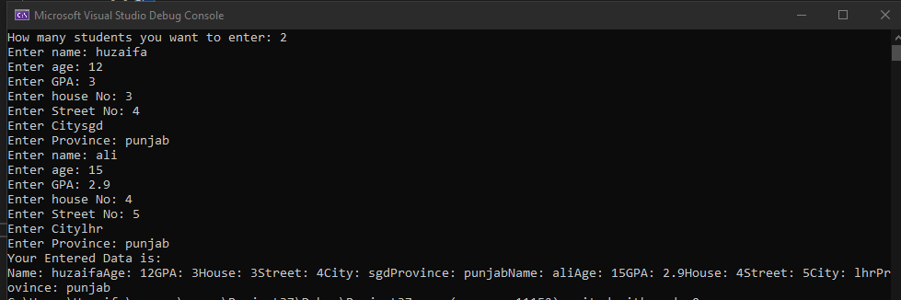

# TASK 3:

#include<iostream>

#include<string>

using namespace std;

union PersonRecord

{

char name[50];

string address;

string phone;

};

int main()

{

PersonRecord pr;

int n;

cout << "Enter your choice: ";

cin >> n;

do

{

if (n == 1)

{

cout << "Enter Name: ";

cin >> pr.name;

}

if (n == 2)

{

cout << "Enter Address: ";

cin >> pr.address;

}

if (n == 3)

{

cout << "Enter Phone: ";

cin >> pr.phone;

}

} while (n > 3);

}

# TASK 4:

#include <iostream>

#include<string>

using namespace std;

class date

{

int month;

int day;

int year;

public:

date() {}

date(int month, int day, int year)

{

this->month = month;

this->day = day;

this->year = year;

};

void showDate()

{

cout << month << "/" << day << "/" << year << endl;

}

~date() {}

};

int main()

{

int month, day, year;

string monthName[12] = { "January","February","March","April","May","June","July","August","September","October","November","December" };

do

{

cout << "Enter day: " << endl;

cin >> day;

if (day > 31 || day < 1)

{

cout << "Wrong Input. Enter Again between 1 and 31 : " << endl;

}

else

{

break;

}

} while (day < 31 || day > 1);

do

{

cout << "Enter Month: " << endl;

cin >> month;

if (month > 12 || month < 1)

{

cout << "Wrong Input. Enter Again between 1 and 12 : " << endl;

}

else

{

break;

}

} while (month < 12 || month > 1);

cout << "Enter Year : ";

cin >> year;

date newDate(month, day, year);

newDate.showDate();

cout << monthName[month - 1] << " " << day << ", " << year << endl;

cout << day << " " << monthName[month - 1] << " " << year << endl;

}

# OUTPUT:

